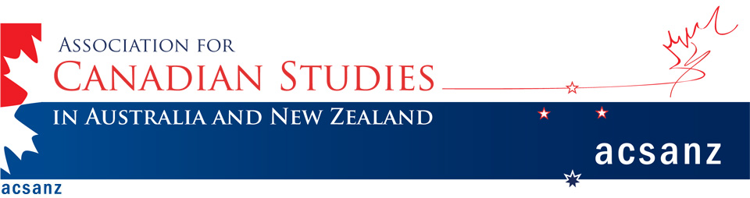
Remembrance and Representation:
Canada, Australia, and New Zealand in World War I

A workshop hosted by the Association for Canadian Studies in Australia and New Zealand (ACSANZ) with support of the Canadian High Commission and Australian National University.

Venue: Australian National University
Date: Sunday 7th Dec - Monday 8th Dec

World War I holds a potent place in Australia, New Zealand, and Canada, a place that will be the subject of significant discussion and debate in the coming years’ commemorations of the centenary of the War. Each country has significant moments in their national mythologies tied to WWI campaigns, including Gallipoli for Australia and New Zealand and Vimy Ridge for Canada. A moment of maturation, the Great War often also stands as a point at which some in the colonies saw themselves outgrowing Britain, its military failures denoting—perhaps for the first time—a broader sense of the limits of British cultural, moral, and social hegemony.

The commemoration of the centenary of the War and each nation’s involvement in it is also likely to provoke critique and controversy. Its shifting and contested meanings should prompt acts of remembering and memorialisation not only against the backdrop of WWI itself, but also within the context of contemporary Canada, Australia, and New Zealand. This anniversary offers the space for a multidisciplinary debate in which to consider what WWI means in relation to contemporary military actions and the diverse roles that the three states have in peacebuilding and peacekeeping, as well as in conflict.

This workshop seeks papers that explore the complex ways in which New Zealand, Canada, and Australia represent and remember WWI. Possible topics include, but are not limited to:

- WWI: defining nationhood and independence
- Race, cultural difference, and nation in WWI
- Writing war
- Australia, New Zealand, Canada, and the Central Powers
- War and modernism
- Changing statehoods
- War, law, and rights
- WWI and peace
- Wartime femininities and masculinities
- Imperial relationships
- The home front during WWI
- Memorials in film, fiction, and fact
- The impact of WWI on today’s foreign and defence policy

Papers will be of 15 minutes duration. Selected articles from this workshop will be published in a special issue of Australasian Canadian Studies, April 2015.

Please send 250 word abstracts to both workshop convenors:
Dr Benjamin Authers Benjamin.Authers@anu.edu.au
Dr Robyn Morris robynm@uow.edu.au by Friday, 5th September, 2014.

