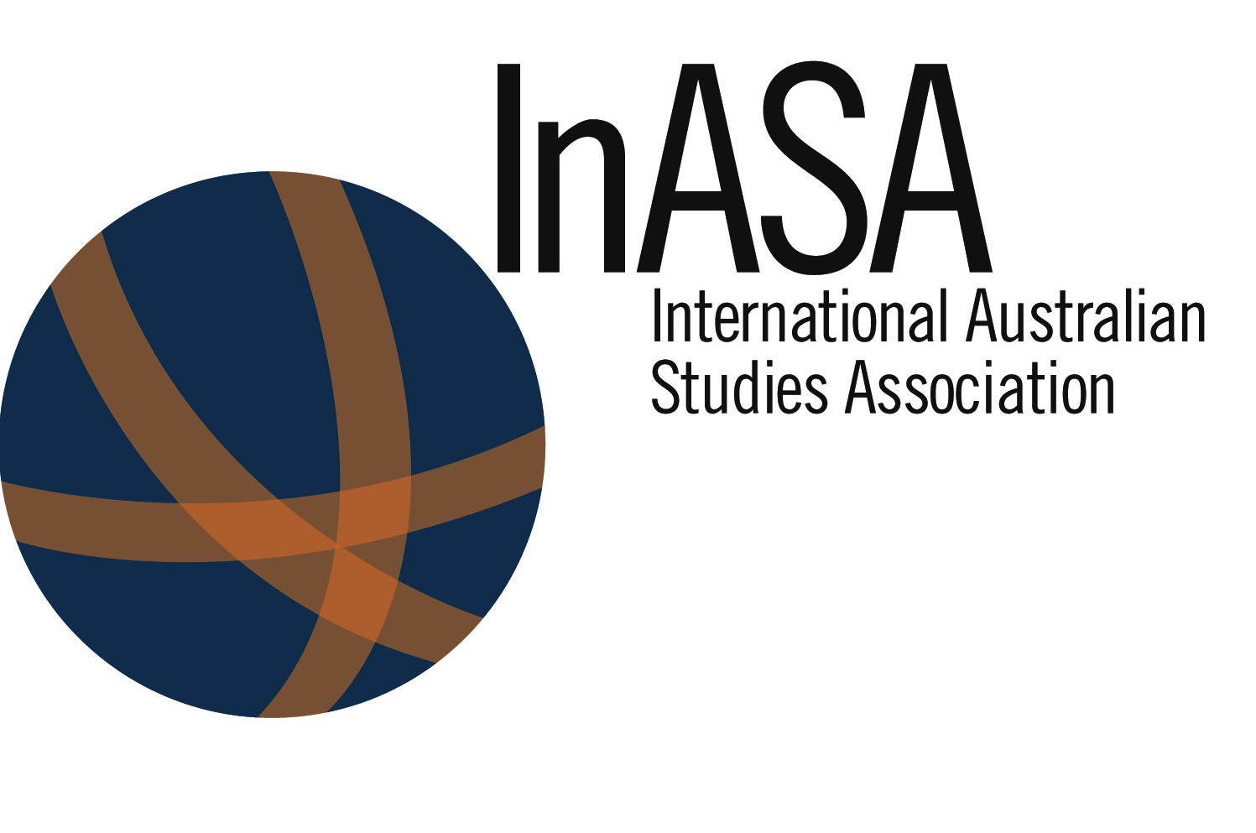

InASA
AGM

9 December 2016
1235-1335 (ND4 ROOM 201 WAADAM)
Agenda Items:

1. Attendance
1.1 Apologies
2. Minutes of Previous Meeting
3. Business Arising
4. President’s Report (to be read)
5. Treasurer’s Report (attached)
6. JAS Editors report
7. Barrett Prize (panelists for 2017 needed; volunteers or suggestions)
8. InASA Peter Lang Australian Studies series update
9. Motions to align period of Committee membership with general membership, ie, 2 years.
10. Executive nominations / positions / elections
11. Other Business
12. Next Meeting: TBA

