ANNOUNCEMENT: FULL VERSION (for InASA Blog)
Professor Robert Breunig has been appointed the 2027 Visiting Professor of Australian Studies at Seoul National University’s Graduate School of International Studies.
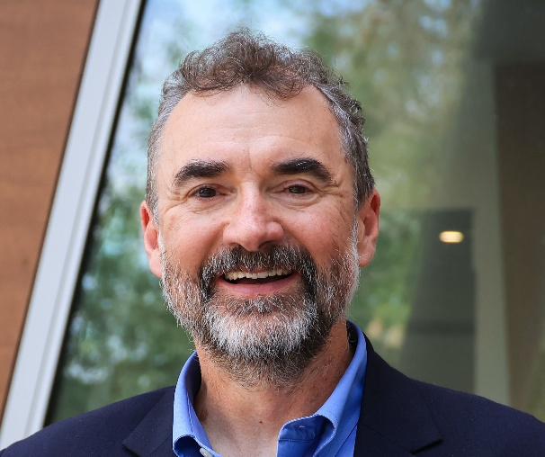
Professor Breunig is an international expert in economics and financial policy, as well as an established leader in both academic and public work across a range of Australian institutional and policy spheres. He is both Professor of Economics and Chair of Tax Policy and Public Finance at Australian National University, Canberra, and the Director of the Tax and Transfer Policy Institute at ANU’s Crawford School of Public Policy.
In his time as Visiting Professor, Robert’s research will develop a comparative analysis across Australia and the Republic of Korea and evaluate how public policy and government programs are engaged with across institutions and populations. As he explains, this research “will extend my current Australian work (applying linked administrative data on: childcare policy, female labour supply, gender equity, and migration) into an explicit Australia-ROK comparison. I'll explore what Australian evidence and research on subsidies and parental labour-market decisions might offer Korea, given its challenges with acute low-fertility and ageing.”
As part of his appointment, Robert will also offer a graduate course within SNU’s Graduate School of International Studies on applying Australian administrative-data research to cross-national policy questions. In both spheres of teaching and research, Robert notes that:
“Australia and Korea share structural challenges—ageing, productivity, women's workforce participation, migration—and my policy-relevant track record, including work that shaped Australia's childcare subsidy reforms, will give the comparison substantial evidence-based heft.”
Robert also expressed an appreciation for the Visiting Professorship as an opportunity to “deepen pre-existing relationships, particularly with the Korea Institute of Public Finance and through the Korea-Australia Tax Symposium I lead at ANU.” During his tenure at SNU, Robert is planning to convene a range of public and academic engagements emphasising Australian Studies, and support opportunities for graduate exchange between ROK and Australian academic institutions. Throughout these initiatives, Roberts aims at “investing in durable networks” between the two nations, as well as supporting the wider profile of Australian Studies. He hopes that, as part of his appointment, his work will make Australian Studies “feel current rather than academic”.
Robert’s appointment constitutes the third annual Visiting Professor of Australian Studies position at Seoul National University. The position aims to build bilateral co-operation between Australia and the Republic of Korea through research and teaching in Australian Studies, and is supported by SNU’s Graduate School of International Studies and the Australia-Korea Foundation, DFAT. Funding for the position is supported by Woodside Energy. The selection process is managed by the International Australian Studies Association.
For further information on this appointment or the position, please contact InASA Secretary Dashiell Moore (dashiell.moore@sydney.edu.au).
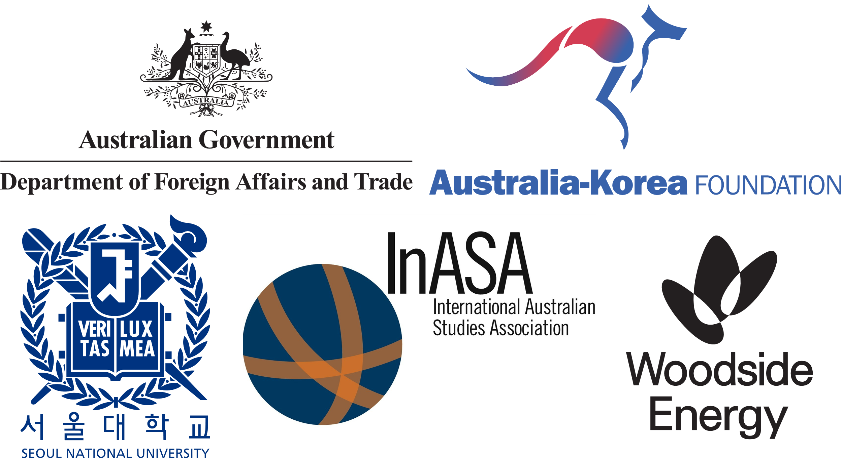

ANNOUNCEMENT: SHORT VERSION (for InASA Socials)
Announcement of 2027 Visiting Professor of Australian Studies at Seoul National University, Graduate School of International Studies
The International Australian Studies Association is pleased to announce the Visiting Professor of Australian Studies at Seoul National University Graduate School of International Studies for 2027 is Professor Robert Breunig, ANU.
Robert Breunig is Professor of Economics and Chair of Tax Policy and Public Finance at Australian National University, Canberra, and the Director of the Tax and Transfer Policy Institute at ANU’s Crawford School of Public Policy. In his time as Visiting Professor, Robert’s research will develop a comparative analysis across Australia and the Republic of Korea and evaluate how public policy and government programs are engaged with across institutions and populations.
Robert’s appointment constitutes the third annual Visiting Professor of Australian Studies position at Seoul National University. The position aims to build bilateral co-operation between Australia and the Republic of Korea through research and teaching in Australian Studies, and is supported by SNU’s Graduate School of International Studies and the Australia-Korea Foundation, DFAT. Funding for the position is supported by Woodside Energy. The selection process is managed by the International Australian Studies Association.

